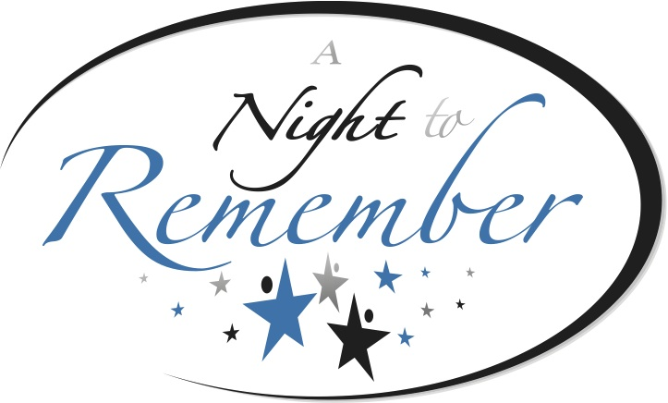

The mission of A Night to Remember is to unite individuals, groups, organizations and other resources to facilitate the educational experiences and cultural enrichment for local students, through local organizations who share the same mission and vision. A Night to Remember is entering its 27th year of existence. During the past twenty-six years the organization has raised over $4,000,000 (four million dollars) to help fund various organizations programs that enhance the lives of Chattanooga’s youth.

These are just a few examples of how the sponsorship dollars are being used.

- Ballet Tennessee utilizes the grant money for their Dance Alive and Talent Identification Program that helps so many of our youth discover the beauty and discipline of dance. The study of dance benefits our personal and cultural development.
- With the support of A Night To Remember the 100 Black Men of Chattanooga has been able to provide financial assistance to college bound students who normally may not have the opportunity to attend or even stay in post secondary educational institutions because of financial need.
- The Bessie Smith Cultural Center utilizes the grant money for various youth and young adult programming including Art Fun Factory. With classes in visual and performing arts being removed from schools or being offered on a very limited basis the need for art programming has increased, especially among students from disadvantaged and low-income areas.
- Chattanooga Girls Leadership Academy used the grant to fund their summer school efforts. As their students come to them with low reading and math skills, they are able to hire tutors for the students, buy supplies and materials for the students to improve their core subject areas and also, supply the students with a snack during the time they are there studying with them in the summer. Without those funds, it would be impossible to have their summer programming.

